Insert Title Here
2WS Integrated Unit Planner
Which class? | Which years? | When? | Who?

Copy or paste your Bush Planner here.

- Context Statement
This helps you focus on your highly unique context. Answer the following questions.

- What does your class look like?
- What does 2WS look like at your school?
- What does the term look like?
- Science Achievement Standards
Paste all the science achievement standards for the year level you have chosen to use. If this is not the first planner for the year, copy and paste your previous one so you can reference which standards you are yet to assess.

Science Understanding | Science as a Human Endeavour | Science Inquiry Skills
Which SU standards have you chosen? | Which SHE standards have you chosen? | Which SIS standards have you chosen?

- Tasks and Resources | - Assessment | - Integrated Learning
What tasks would work well with the topic and what resources do you need? | How will you measure student achievement and reflect upon your impact? | What other areas of the curriculum can you include?
 | Diagnostic | Literacy
 |  | Numeracy
 | Formative
 |  | First Language
 |  | 1.
 | Summative
 |  | 2.

High Impact Teaching Strategies
- Unit Sequence (WILF) | - Learning Intentions | - Success Criteria

- 2WS Checklist - Am I doing 2-Way Science?
Week | How did I involve Anangu in leading the learning? | What learning did we do on Country? | What Science did we teach? | How will I include Anangu next week?
#1
#2
#3
#4
#5
#6
#7
#8
#9
#10

- Tracking and Assessment
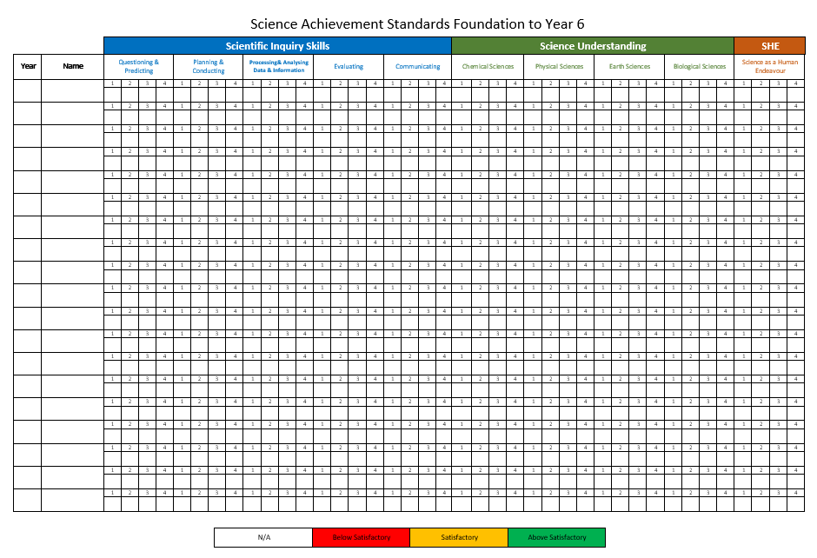
- Impact
Comments  What outcomes have your students achieved? | Insert evidence of your impact here.  These may be photos of qualitative evidence or screen shots of quantitative evidence.  Remember, this isn’t about personal judgments, it’s about reflecting (preferably with a colleague(s)) about your impact and working on some effective next steps (growth).
Positives
What worked well?
Challenges
What was difficult? Try and focus on things you control.
What’s Missing?
What do you need to improve your impact?
Commitments
What are you going to do about it?

